CST 352 – Lecture 3
Wilsonville, Spring 2022

Ch 5, Scheduling, interrupts, context switching

Primary challenges for implementing threading in OS:
- Scheduling (time-slice sharing between threads)
- Syncrhonization (mutex, event, etc.)

Kernel Threads vs. User Threads

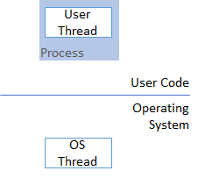

One-Level Model (1-1):
- Each user thread maps 1-1 to a kernel thread
- All scheduling and syncrhonization done in the kernel
- All threading library calls are syscalls (require trap/interrupt)
- Simple, but expensive
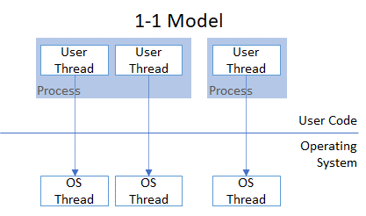
Two-Level Model, Single Kernel (1-N):
- Multiple user threads supported on a single kernel thread
- Each process has only one kernel thread
- Threading library simulates multiple user threads
- Uses queues for running threads and waiting threads
- Some-what complex, but more efficient than 1-1
- Suffers when application makes a syscall that actually blocks the 1 kernel thread
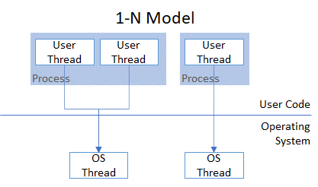

Two-Level Model, Multiple Kernel (M-N):
- Multiple user threads supported on multiple kernel threads
- Kernel threads are allocated as needed to prevent blocking the app with a sys call
- More complex, but most efficient

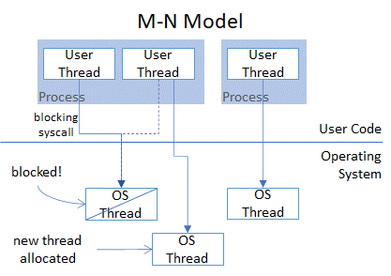

Straight-Thread Implementation
See book pg. 170
Based on 1-N model
No interrupts: Each thread given control and voluntarily relinquishes control, e.g.
by calling a thread library routine, like Mutex.Lock()

Thread object with context, referenced by…
- Current thread global
- Queue of runnable threads (run queue)
- Queue of waiting threads per mutex (mutex queues)

Diagram from book pg. 171

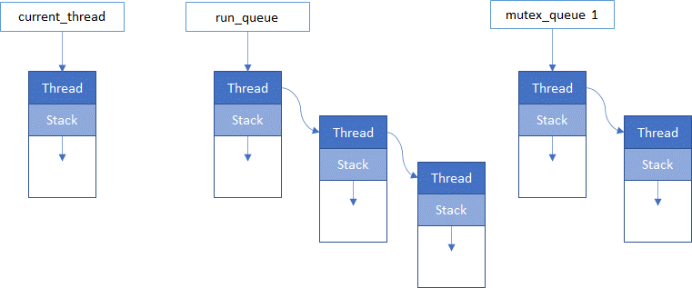

Mutex.Lock()
If mutex available, lock mutex, else
Insert current thread in mutex wait queue and switch context to next in run queue

Mutex.Unlock()
If there are threads waiting on this mutex, queue the next one for running, else
Unlock the mutex

Switch context between threads…
Insert current thread at the tail of the run queue
Get next runnable thread and make it the current thread

How does this whole thing work?
Specifically, how is the processor actually shared between threads in this scenario?
Where is the context for each thread stored?

How does this work with multiple processors?
Requires allocation of processor to a thread when the thread is ready to run
Special “idle-thread” is allocated to each processsor. Runs next runnable thread

Challenge is how to implement mutexes between processors

Spin Lock uses an atomic instruction to try to set a value to 1 (locked) or 0 (unlocked)
Basically repeatedly attempts until it acquires the lock
Simple, but potentially wasteful of CPU cycles

Blocking Lock adds a thread sleep to the Spin Lock
Conserves CPU cycles, but potentially expensive to sleep/wake threads

Interrupts
See book pg. 177
Concepts:
- Interrupt: Signal from CPU that stops normal execution, calls interrupt handler
- Interrupt Handler: Special code that runs in kernel mode on an interrupt
- Deferred Work: Thread’s code that is executing before interrupted
- Preempt: Force one thread to yield to another thread

Pre-emptive kernels
Force threads to share by time slicing
Use interrupts to ensure context switching between threads

Challenges, solved with mutexes and spin locks:
- Synchronizing access to shared OS data structures during interrupt handlers
- Synchronizing access to shared OS data structures across multiple-processors

Variety of interrupts available on the CPU
Masking allows the interrupt handler to complete and not become interrupted itself
Interrupt handlers need to be very fast to keep system responsive,
Typically create deferred work, by adding to deferred work queues

Interrupt Handler:
- Handle specific interrupt (queue deferred work if appropriate)
- Work on queued items until empty
- Return from handler (back to interrupted thread)

Example: interrupts on Windows:
29 Inter-processor
28 Clock
…
4 Device 2
3 Device 1
2 DPC – Deferred Procedure Call
1 APC – Async Procedure Call
0 Thread

Scheduling (pg. 193)

Strategies:
- Simple batch – queue of jobs, OS decides which batch to run next
- Multi-batch – queue of jobs, OS decides which batches and how to share
- Time-sharing – many processes/threads, OS decides how to share between threads
- Shared server – many clients, OS decides how much resource for each
- Real-time – high performance requirements, OS must balance to meet needs

Time-sharing explained (with Windows as example)

Multiple threads, each with…
Priority (may be raised/lowered over time)
Time Quantum (how long before thread can be preempted by same priority)
Foreground vs. Background (foreground for user interaction)
Real-time vs. Normal
Processor Affinity (which processor to use if possible)

Threads are moved between various states…

Diagram from book pg. 211
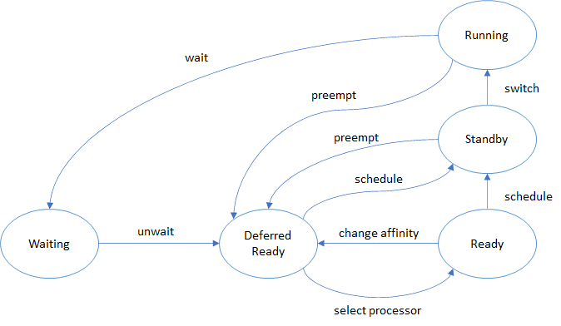

Thread starts in Running state
Calling a blocking procedure switches thread to Waiting state
Interrupt handler moves Running thread to Deferred Ready
Scheduler balances priorities and moves to Standby,
May change processor first through Ready state
When the current running thread gives up processor, or is preempted,
the next Standby thread is moved to Running

